Cure – Boys Don’t Cry
[Intro]
A | bm | c#m | D D c#m bm [4x]
^^^(triplet)
Melody only on 2nd & 3rd times

[Verse] A | bm | c#m | D [2x]

[Chorus]
c#m | bm [4x]
Intro chords [2x] with the melody

[Bridge]
E | f#m7 [3x]
D | E

[Outro] is Intro
last two times ‘break’ the chords

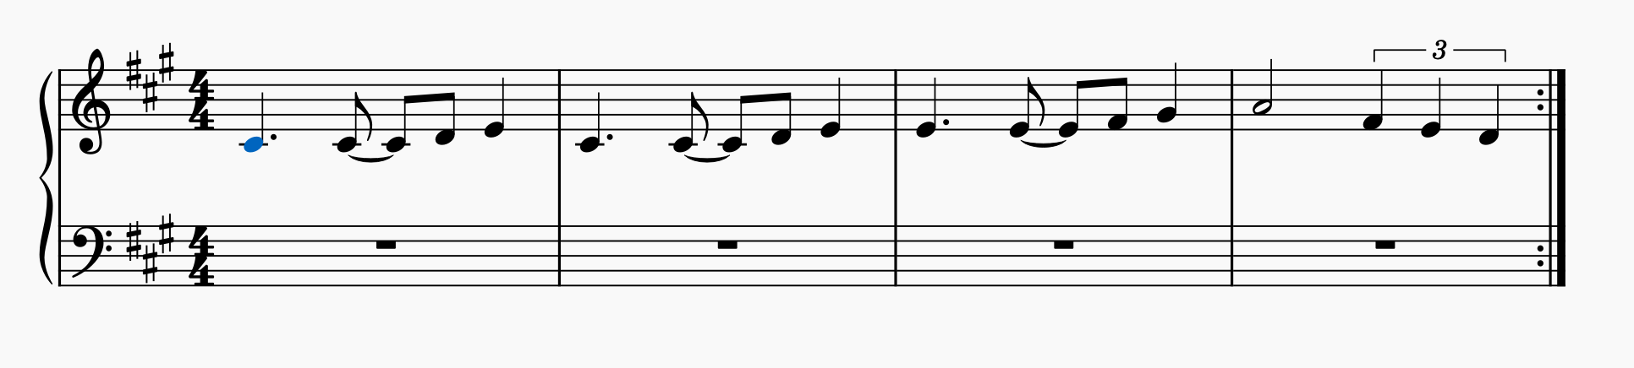
Plan: Intro 4x (melody 2nd & 3rd x only), Verse 1, Chorus, Intro 2x, Verse 2, Chorus, Intro 2x, Verse 3, Bridge, Verse 4, Intro 4x (hold chords on 4th x)

